What are our health and safety responsibilities?

As an employer, Hair and Skin have a duty of care under health and safety law to support employees on a day to day basis and during outbreaks such as coronavirus, to take precautions to prevent exposure to risk of infection on accident. As an employee we all have a duty of care to each other and our guest health and safety at the salon. This is our plan describing actions currently in place to reduce the risk of infection but also how we will respond to the new normal during the COVID-19 pandemic with in the salon environment and our commitments moving forward as and when we return to work.
What Is Cross infection and why do we need to consider this regarding day to day salon environment and in our current pandemic heightened measures.
A cross infection is the transfer of harmful microorganisms, usually bacteria and viruses. The spread of infections can occur between people, hand to eye, mouth, nose contact, unsterile pieces of equipment, airborne particles or within the body. These infections can cause many complications, reactions, infection, illness or in COVID-19 case possible death.
What do we need to consider and already have in place in the salon to help control cross infection?

When performing any type of Hair, Beauty or Aesthetics treatment basic hygiene measures and health and safety are already in place at the salon and included in the following list helping to reduce cross- infection risk reduced:

Surfaces and equipment are washed daily with antiseptic solution.
Tools are always sterilised with barbicide and UV light.
Floors are hovered and mopped daily
Caps and lids on bottles and jars should be immediately replaced when you have used them to avoid spillage and bacteria entering a open product.
Towels and any linen should be changed for each client and all towels at the salon are towles disposable, one use.
Couch roll is always used and changed between clients
First aid kit and eyewash are available on the premise in case of emergency
Jo Fulton Tolley has a certificate in First aid at work and CPR in case of emergency
All paper waste is disposed immediately into a covered container and disposed at the end of each day. Waste bins are disinfected daily
Toilets and washbasins are cleaned daily with the appropriate chemicals
All spillages are wiped up immediately
Disposable gloves are always available
Use antibacterial hand wash and hand wash basins are available for staff and hands are washed between every client.

Personal Hygiene in the salon currently to help reduce risk of cross infection.

As well as the above basic actions it is also the team members responsibility to adhere by high standards of personal hygiene to avoid cross infection at all times these include:
Always wash hands, preferably with an antibacterial soap prior to the treatment and ensure nails are clean.
Wash hands after each treatment
Long hair should be tied back
Take regular showers
Remove jewellery before treatment
Wear PPE where instructed
Wear clean clothes or uniform provided every day.

Understanding COVID-19
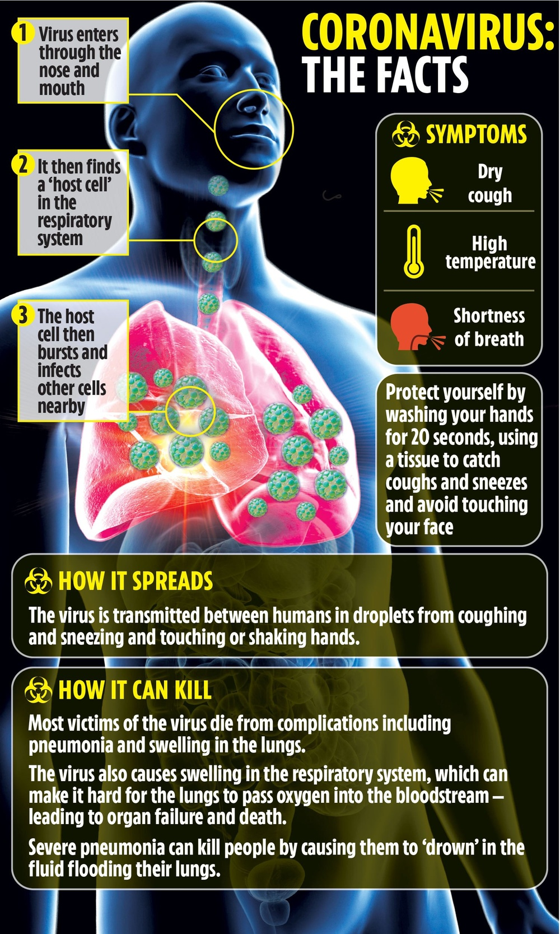
In light of the recent outbreak of this wide spreading virus it is even more important that we take salon hygiene to the next level and that we ensure our staff and clients know how to take appropriate preventative measures in order to reduce the chances of the virus transmitting between clients and staff whilst in the salon environment.

What is COVID-19?

COVID-19 is described by the World Health Organisation, at time of writing this document as:

Coronavirus disease (COVID-19) is an infectious disease caused by a newly discovered coronavirus.
Most people infected with the COVID-19 virus will experience mild to moderate respiratory illness and recover without requiring special treatment. Older people, and those with underlying medical problems like cardiovascular disease, diabetes, chronic respiratory disease, and cancer are more likely to develop serious illness and may result in loss of life.

Transmission of the Disease
The COVID-19 virus spreads primarily through droplets of saliva or discharge from the nose when an infected person coughs or sneezes, through the air or through skin to skin, eye, nose, mouth, face contact. Or through contact with any contaminated surfaces, e.g. door handles. Due to the airborne nature of these droplets, the disease can spread very easily. However, a high standard of infection control protocols can significantly reduce the chances of the virus spreading.

In light of all the information and our nature of work, on a one to one basis in close and personal proximity during normal salon circumstances risk of cross infection would be small, but in light of the serious nature of COVID-19 this would potentially effect risk and the health and safety of our clients and staff.

To combat this, all elements of the business have been considered and addressed in the following risk assessment, looking particularly at the spread of COVID-19 with the natural flow of the salon.

Hair and Skin COVID-19 Risk Assessment

Hazard | Description | Possible examples | Action taken | Who responsible
Front door  Walk in enquires  Early clients or clash of appointment time  Clients bring friends or family members | Staff and clients opening and closing the door on entrance and exit to the building  Potential enquires or clients without an appointment walking in off the street.  Hair and beauty appointment at the same time.  Clients bringing plus ones with no salon appointments. | Possibility of hand to hand contact through contamination leading to cross infection on the push bar, door frame, glass and handle both on entering and exciting the building.  Person walks in and breaks 2m recommendation, clashes with timing of booked client arriving or leaving the salon, coming into proximity, possibility of cross infection increased  Friends and family double the risk of infection to both clients and staff and form staff to client. | Front door to be wiped down between every entry and exit from the building, with disinfectant, 70% alcohol spray or barbicide.  Windows and doors to be cleaned by professional window cleaning in addition once a week  Where possible same staff to open door and avoid clients interacting with the door reducing risk.  Front door to be locked. Notice on the door to say call or go online to book.  Have an outside, roped off area wating area, with two waiting areas measured out 2m apart  Client told prior to treatments not to arrive early to prevent unnecessary increased risk.  Friends and family will not be permitted in the salon  Clients will not be allowed into the salon until their  appointment time, previous client has left and full cleansing procedures of work area has been completed.  Where possible Beauty appointments to start at 10mins past the hour for the day and Hair appointment on the hour. To create staggered, enter and exit and flow of people in the salon at one time  Only one stylist and beauty professional to be working in each department at one time of the day.  Rotas will be altered to accommodate longer opening hours but less staff in the building and therefore less clients at anyone time, creating less risk and a more manageable controlled environment. This will be detailed further in the document to follow | Hair and Skin staff  External contractor.  Hair and Skin staff and Clients  Hair and Skin staff and Clients  Management and reception  Management
Salon Greeting/ departure? retail purchase and payment  Client to receptionist contact, Meeting and greeting  Taking coats  Client to client and Staff to client contact  Work bays  Refreshments  Entertainment  Payment  Waste disposal | Welcome to salon, often greet by physical contact, tap on back, hug, verbal interaction less than 2m  Clients handing coats or jackets worn outside of salon to staff to place in wardrobe.  In normal circumstances, busy salon client to client in close proximity chair to chair in hair dressing department. Less than 2 meters.  Beauty less risk of client to client cross over contact as two separate rooms and defined zones for all other treatments more that 2 meters apart from  Both Hair and Skin professionals during treatment work contact to contact, hand to hair, hand to face, hand to eye contact, there is no other way to carry out their professional treatment.  One “work bay” Beauty room, Pedicure area, make up area, beauty room or Hair stylist stations is shared by many different clients over the period of a day.  Staff making hot or cold beverages for clients to consume during their treatment  Staff breaks and refreshments  The providing of magazines or Pads for entertainment during the Clients treatments  The exchange of money, cash or card payment after treatment  The disposal of all waste, in correct labelled bins, and removal by correct service, clinical waste or council depending on the nature of the disposed item.  We currently have both business and clinical waste. | Cross infection through one to one physical contact or through the passage of airborne particles within close person to person proximity  Possible contamination of clothing from outside salon passed to staff, handling items whilst hanging them up or between items in the wardrobe.  Cross infection through one to one physical contact or through the passage of airborne particles within close person to person proximity  Cross infection through physical contact or through the passage of airborne particles to seats, couches, tools and fittings used during treatments  Risk of hand and mouth to cup cross infection on reusable glassware and crockery  As above  Cross infection through physical contact or through the passage of airborne particles to pages, covers, pad to tables or furniture or person to person contact.  Cross infection through physical contact or through the passage of airborne particles from person to person if que forms at payment area  Waste segregation at the point of generation enables the safe management of salon wastes. It is an essential part of ensuring that salon activities don’t pose a risk of infection to staff or clients and anyone else coming into contact with the waste containers.  Salon waste segregation processes are vital to ensure the waste is stored, transported and treated correctly. By adhering to waste segregation processes, different waste types can be processed using the most appropriate treatment or disposal process reducing risk of cross infection and spread of COVID-19 | No physical contact of any kind.  Flow of movement to be marked out on shop floor with specific zones and 2m apart restrictions with rope barriers to maintain activity, see shop floor plan for full instructions  Clients asked not to bring external clothing where possible before appointment  Clients are asked to place outside clothing items inside suit bags and hang them once doing this themselves.  Also remove them after treatment themselves.  After each client Suit bags are sanitised with disinfectant, 70% alcohol spray or Barbicide.  Or either end of a running rail.  Hands or gloved hands are washed immediately after.  PPE  A PPE table will be at the entrance to the salon , when clients arrive and after they have removed any outside clothing that they may have worn in, they will then be asked to sanitise their hands and then put on, apron, gloves and a mask.  Clients will not be able to continue into the salon or commence with treatments with out these on and they must be worn through out the duration of the stay in the salon.  Staff PPE station will be at the service station at the back of the salon.  Before each new client staff must wash all their hands in line with the NHS guidelines later in this document.  They must then put on a mask, gloves, apron and eye googles.  Staff will not be allowed to work without full PPE  Workstations will be reduced from 7 stations to 4 stations  Measured 2 meters apart with a max of 3 clients and one professional in the building at anyone time  Only one Hairdresser and one beauty professional on any one shift.  After each client’s treatments is completed a full deep cleanse of particular work bay must be completed.  Disinfect, bed. Couch, seats, including feet legs and bases of furniture, and mop with disinfectant 2m around in and around the area.  Lamps, trolley’s, hairdryer, straighteners. And Mirrors.  All tools must be placed immediately into the barbicide jars. Soaked for 20 mins and then placed in UV steriliser.  Staff must then dispose of their PPE wash their hands and place new PPE on before new client will be allowed into the sterilised bay.  No refreshments until further notice  All staff must have their own dedicated cups, plates, knife etc  Stored in own spot in staff room, this is for their use only.  All staff must make their own refreshments and wash up their own sets until further notice.  No entertainment to be provided until further notice  NO CASH PAYMENTS until further notice  All payments to be contactless  Card reader left on Exit/ retail/ PPE disposal table.  Client selects products if they want them, staff member process payment from phone or pad at 2m distance, client then can pay using the card reader on table.  Clients remove PPE and disposed in clinical waist bin as detailed in next point  They are then invited to collect coat if they bought one, retrieve themselves and then leave the building.  Only one client at a time will be allowed through the last zone on the way out to prevent cross infection and external cross infection from house to house, reducing risk.  Usually bins are away from view, there will now be visible orange bins in both departments at the Staff and client PPE designated areas for disposal of used PPE, masks, gloves and aprons must go into these bins, black bins are for all other domestic waste only | Hair and Skin staff and members of public (clients)  Hair and Skin staff and members of public (clients)  Hair and Skin staff and members of public (clients)  Hair and Skin staff  Hair and Skin staff  Hair and skin staff  Hair and skin staff  Client and Hair and Skin Staff.  Client and Hair and Skin staff  Hair and Skin staff and Clients
NB: Services will be declined for any client that exhibits signs of illness

Where hand washing is mentioned in the above risk assessment either by client or staff, we will be following the following guidance
Hand washing with soap and warm water must proceed after the following salon activities
Prior to starting any procedure
After setting up equipment and/or sterile area
At the client’s side prior to treatment
After the procedure has been completed and before leaving the client
After clearing and cleaning equipment in the treatment bay
After any physical contact person to person
Every 20 mins where this do not apply
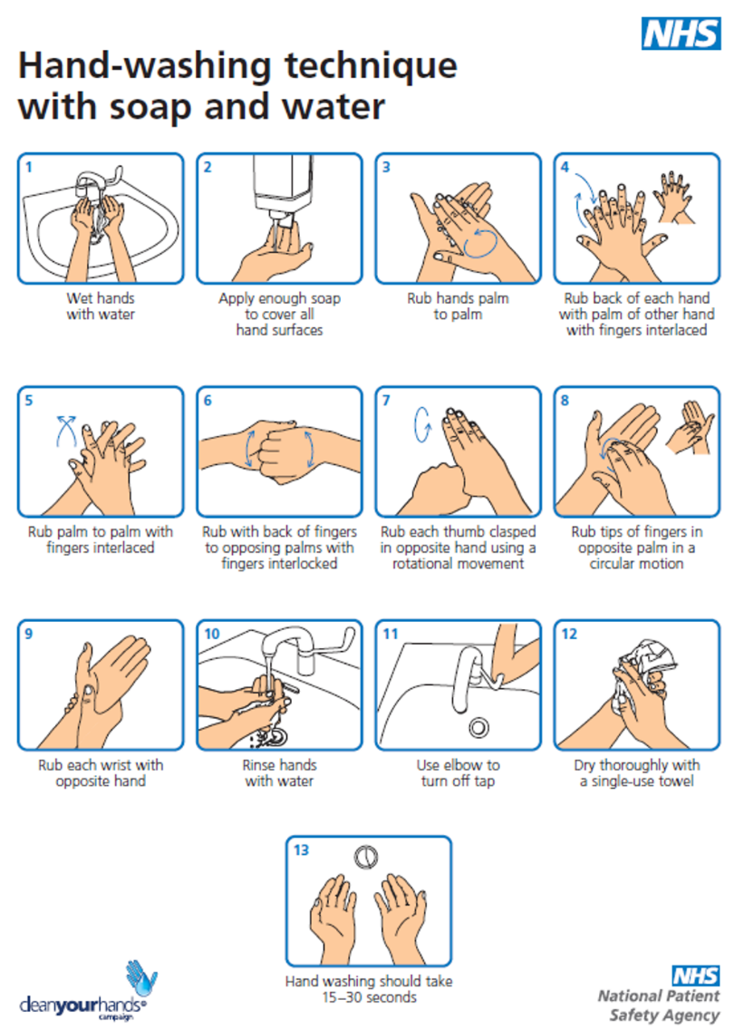
(in addition see further NHS advise on hand sanitising)

Hand Sanitisers
Alcohol rub based preparations offer solutions when time and facilities are restricted. This is ideal rapid can decontamination that should only be used when soap and water are not to hand. Alcohol rubs will not remove visible dirt or material.
Antiseptic hand wash solutions use a chemical approach do you remove and reduce resident flora and remove or destroy transient flora. This type of chemical removal prepares hands for a surgical or aseptic procedure and is also used following contact with blood or body fluids. Typically, this product would be Chlorhexidine based, e.g. Hibiscrub.
Hand Drying
Micro-organisms transfer most effectively from wet surfaces so always dry hands thoroughly. Use good quality paper disposable hand towels and not cloth towels as these harbour bacterial.
Warm air dryers have the potential to spread airborne pathogens so if you have a choice, go for paper towels.
Clarification on terms used in the COVID-19 risk assessment and specific information.
Disinfection
Disinfectants of chemical agents which are capable of reducing or destroying the level of micro-organisms, however certain viruses and bacterial spores remain untouched by disinfectants.
Disinfectants must be EPA-registered and labelled as bactericidal, viricidal and fungicidal. No product will be labelled for COVID-19 yet, but many will have human coronavirus efficacy either on their label or available on their websites. The EPA has approved any product that has tested as effective against human coronavirus, to make a claim for COVID-19 at this time
In the salon we use, alcohol wipes, spray, disinfectant and disinfectant sprays and barbicide.
Sterilisation
Sterilisation renders an object free from micro-organisms including viruses and bacterial spores.
There are many forms of sterilising, the main types being:
Heat
Boiling and steaming under pressure
Ultraviolet rays
Gas chemicals
In the Salon we use UV light, heat, boiling and steaming
PPE (Personal Protective Equipment)
The use of PPE protects both the professional and the client from the risk of cross-infection. It includes disposable gloves, disposable aprons and, in some cases, masks and eye protection (goggles).
Disposable Gloves
Disposable gloves are worn to provide a protective barrier for both practitioner and the client, limiting contamination. Disposable gloves should be worn only once and never washed.
It must be noted that wearing disposable gloves is NOT an alternative for the need a hand hygiene. Hands should be washed before putting on disposable gloves and after removing them. Sterile gloves must always be used when treatment has the potential to create blood and bodily fluids.
When putting on and removing gloves, it is important not to touch the outside of the glove as this renders the object of putting gloves on in the first place null and void. Sensitivity to natural rubber latex is commonplace and alternative gloves must be available; for example, non-latex non-powdered, non-nitrile gloves.
Disposable Plastic Aprons
Wear a clean, sterile disposable plastic apron to protect and prevent cross infection from clothing during treatment. The apron should be worn as a single use item and then discarded as clinical waste as soon as a treatment is completed. Aprons should be worn when cleaning or decontaminating equipment.
Masks
Masks are single use items and should be used when providing care within 3 feet of a client who is coughing and sneezing, or if the professional is coughing and sneezing.
The wearing of surgical masks also helps reduce inhalation of chemicals or other airborne substances or particles in this case COVID-19
Clinical Waste
All contaminated clinical waste should be disposed of in an orange bag and must be incinerated. Contaminated waste includes but is not limited to in our salon, gloves, masks, aprons used waxing strips Clinical waste must be stored separately from general waste.
In this time this will also include disposable towels and highlight used pouched due to contact form client.
SHARPS
All sharps must be disposed of in a dedicated yellow sharps container which must conform to national standards. Sharps containers need to be disposed of when three-quarters full. Containers need to be incinerated. Refer to local policy for specific rules and regulations. Do not attempt to dispose of sharps in any receptacle other than certified sharps containers.
At the salon we use sharps bins for all antiwrinkle injectable treatments by our nurse and micro needling cartridges, we also have some hair product cartridges that are disposed of in this way.
Domestic waste
All other waste

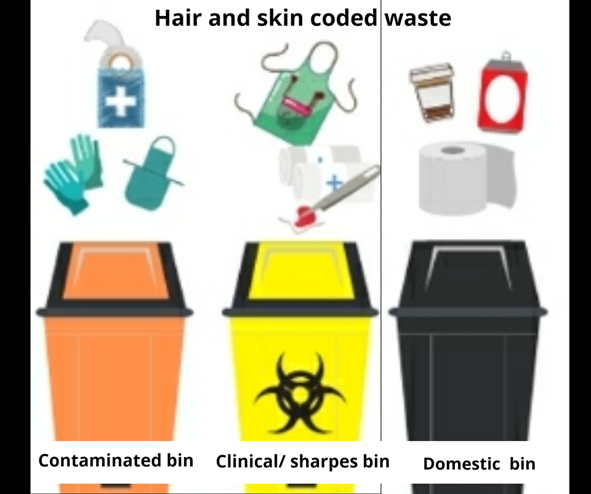

Directions of flow and staff to staff, client to client ratio control
To minimise client to client contact and client to staff contact a direction of flow will be created within the salon, with specific zones, mentioned in the risk assessment, this helps to control potential spread of infection by limiting the number of people in any one area, maximising 2m distance as much as we can and being able to effectively sterilise areas to prevent cross infection.
In addition, staff working hours will be limited only one professional in at any one time, again helping to keep footfall down and reduced cross infection risk, protect the 2m rule.
See attached documents:
H1/2 = Hairdresser one and two (ground floor)
B1/2 = Beauty therapist one or two (basement)
ZONE 1 = blow dry bar
ZONE 2 = Full length mirror zone
RA = Aesthetics room
BR = Beauty room
Option A
Restricted staggered hours working in designated zones
ONLY ONE PROFESSIONAL WORKING PER FLOOR
Staff | 8 | 9 | 10 | 11 | 12 | 1 | 2 | 3 | 4 | 5 | 6 | 7 | 8
H1(zone1) |  | IN | IN | IN | IN | IN | IN
H2(Zone2) |  |  |  |  |  |  |  | IN | IN | IN | IN | IN | IN
B1 (RA) | IN | IN | IN | IN | IN | IN
B2 (RB) |  |  |  |  |  |  | IN | IN | IN | IN | IN | IN | IN

Option B
Normal staff working hours still in designated zones, TWO STAFF WORKING PER FLOOR 2M RULE IN PLACE NO MORE THAN TWO CLIENTS PER THERAIST IN SALON AT ONE TIME
Staff | 8 | 9 | 10 | 11 | 12 | 1 | 2 | 3 | 4 | 5 | 6 | 7 | 8
H1(zone1) |  | IN | IN | IN | IN | IN | IN | IN | IN | IN | IN | IN
H2(zone2) |  | IN | IN | IN | IN | IN | IN | IN | IN | IN | IN | IN
B1 (RA) | IN | IN | IN | IN | IN | IN
B2 (RB) |  |  |  |  |  |  | IN | IN | IN | IN | IN | IN | IN

There is a possibility that government will not allow beauty to open initially.
These rotas will be reviewed regularly in line with government instruction, we expect the next announcement to be Thursday the 8th of May, following this hopefully we will have a guide and timeline on our return to the salon and can make a discision rota we will use following this.
Friday the 1st of May2020, Shops to remain closed was updated on the government website and our professional are still on this list.

New floor layout and client flow and area:
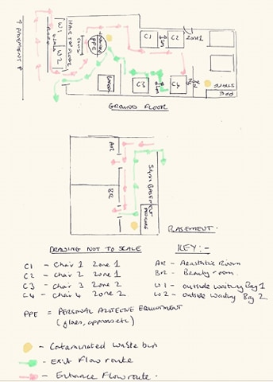
Returns to work action plan:
All staff to complete sterilisation and disinfection refresher training before returning to salon.
Through barbicde website http://www.hairproducts.co.uk/info_barbicidecertification.php
Staff will return to Salon a week before salon opens to clients. This is for additional Health and safety training, salon layout, deep cleaning and client bookings.
Staff will be given hours over the week to attend, staff may not all be allowed to be in at the same time.
Signage and new shop floor layout:
Signage designed and ordered, be posted on form door that states services will not be offered to or given by anyone who is sick or exhibiting signs of illness. Clienta should be asked prior to a service if they have been sick or exposed to someone who is sick. If so, services should be deferred for 10-14 days.
Window signage to advise door is locked and to book online or call the salon
Create outside waiting with clear 2m sections
Masking tape out entrance and exit flow on the floor and highlight PPE Zones for staff and clients and payment zone
Chairs measured and moved 2m apart every other chair removed.
Waiting area and communal area chairs removed
Beauty waiting area and reception removed
Checklist of Supplies Needed:

Be prepared before we receive customers to stock take and order not limited to:

Hand hygiene supplies including access to good quality soap, hand sanitiser
Disposable gloves.
Eye protection, single use goggles.
Clinical waste bags.
General purpose detergent and chlorine based disinfectant solutions.
Dettol or Surgical Spirit.
Suitable surface cleaners.
Disposable couch roll.
Salon sterilisers Barbicide
Floor cleaner Zeflora
Glass and window cleaner
Cleaning cloths, wipes
Alcohol wipes
Toilet cleaner
Disposable towels
Bleach
Washing-up liquid
Liquid disinfectant
Disinfectant spray
Alcohol based hand sanitiser
Sharps Box
Clinical waste bags
Clinical waste bin
Bin liners
Disposable gloves
Rubber gloves
Yellow mop and mop bucket

Pre opening cleaning list:
Stock and retail:
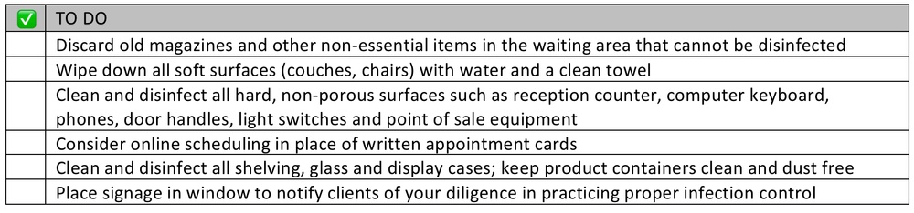
Work bays:
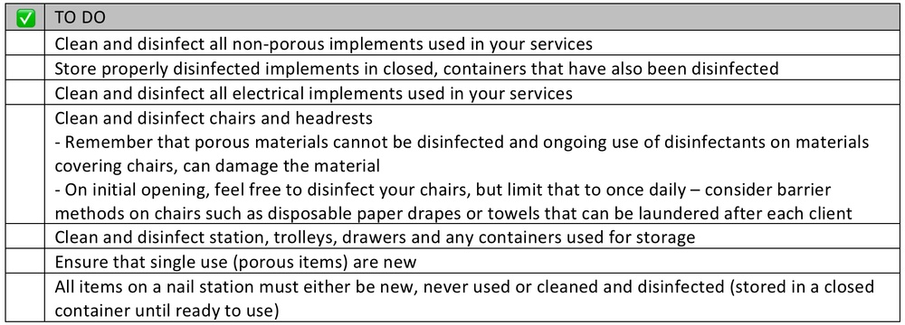
Treatment rooms:
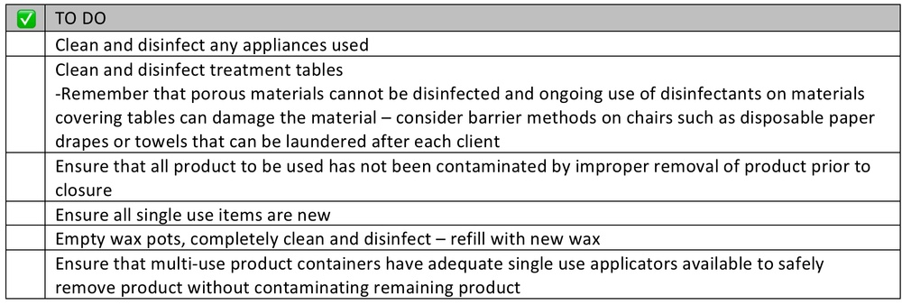

NB: Thorough deep clean of toilet and staff area in addition before opening.

Shift lead will be allocated every shift and it will be their responsibility to check all these daily task, tick sheet to be created in addition to these all being complete before opening:

Weekly Tasks:
• Dust window ledges, light fittings and fixtures
• Disinfect skirting boards
• Polish windows and picture frames
• Wipe down walls
• Tidy and disinfect cupboards
• Tidy,disinfect organise products
• Ensure feminine hygiene and clinical waste disposal bins have been emptied

Daily Tasks shop floor/ staffroom/ beauty
• Sweep floors thoroughly
• Vacuum carpets and door mats
• Mop floors
• Clean and disinfect chairs, beds and work station, feet
• Polish mirror, glass and chrome surfaces
• Tidy, organise and re-stock product displays
• Empty and disinfect bins
• Clean and disinfect wash hand basins and toilets
• Re-stock toilet paper, hand towels, hand wash and hand sanitiser
• Launder capes
• Clean and disinfect all tools and equipment
• Clean and put away cups, glasses, spoons etc
• Clean coffee machine and all kitchen equipment
• Clean and disinfect door handles and grab handles

Appointments:
All services must be scheduled with adequate time in between appointments to properly clean and disinfect. Employers should be held accountable for allowing their employees to have enough time to allow for proper disinfection without repercussions. Patrons should be asked to wait outside or in their cars until they are called for their appointment. Appointments should be staggered to avoid multiple people in the waiting areas.
Double Booking:
This should not be done unless each patron can be left in a single chair throughout the process and distancing measures maintained. Limiting the movement of patrons throughout the business reduces risk to both patrons and staff.
Order of re booking:
Calls to move clients forward will be systematic, from the first of August, so first people to book first to get new appointment.
Calls will take longer as need to advise everyone no cash, no friends, no waiting, no walkin, no overcoats where possible, no refreshments, PPE and payment expectations.
Text message blast will go out after this first week after these bookings have moved forward to say we are open.

Our Aim
Our aim is to through this document provide clear working rules for staff and expectations of our clients to reduce risk and potential spread of infection through health safety and hygiene stipulations. The temporary restriction of the old normal with in the salon environment created to deliver the safest environment possible for our clients, to instil our professionalism and demonstrate how we will deliver our duty of care in turn instil confidence to our clients when visiting our salon
Working document declaration
This is a working document; this means that this working model is constantly under review in line with government directive. As we move from our new normal to back towards before pandemic normal, policy will be reviewed, and measures gradually lift reflected in salon operations.
We will monitor this through continued risk assessment and communicate this through updating our policy, displaying it online, website, through social media and through calls, text and emails.
You can also call with any concerns or questions on 01843 297307 or email hairmargate@hotmail.com

